TASK 4 – Task Sheet

GOOGLE CLASSROOM

Tasks:
1. Implement 5 different models to perform Random Forest for 5 different dataset that prevails in csv format
2. Data Ecoding
Topics: LeetCode
1.Solve 5 LeetCode Problems
Topics: GitHub
1.Submit this week complete work to your GitHub repo.
Topics: LinkedIn
1.Share your weekly task overview in your LinkedIn page with proper messages and images. Showcase Your work to public.
Topics: Video Recording in English Language
1.Record a self-video explaining your weekly task, what all challenges you faced and what output you got from this week.
2.Record a self-video explaining any one of the latest technologies in your interested area.
Extra Works
1.Build at least 30 connections in LinkedIn with HR, CEO’s and People from your Domain (Don’t send 30 requests in single day. Try to send 3 or 4 requests daily. Sending bulk connection requests in single day may spam your profile. Build your LinkedIn page as your Brand).

NB: Students, please fill the below details in proper way and upload this word file in to your google drive and share the link in google sheet.
Student Name: | ANUPAMA P T
Semester and Branch: | BTECH CSE(AI&DS)
Email id: | anupamaasrinivasan@gmail.com
Whether you completed all the assigned task in this week (Yes/No):

1. Implement 5 different models to perform Decision Trees for 5 different dataset that prevails in csv format

Random Forest is an "ensemble" algorithm, meaning it combines many Decision Trees to get a more accurate and stable result. It is excellent for handling complex, real-world data because it's resistant to overfitting and tells you which features are most important.
Here are 5 datasets to help you master Random Forest classification and regression:
1. 🚗 Car Evaluation Dataset (Multiclass Classification)
- Goal: Predict the safety or acceptability of a car based on features like price, maintenance cost, number of doors, and luggage capacity.
- Why it's good: This dataset is entirely categorical. Random Forest is famous for handling categorical data well without needing extensive "One-Hot Encoding."
- Direct Link: Kaggle - Car Evaluation
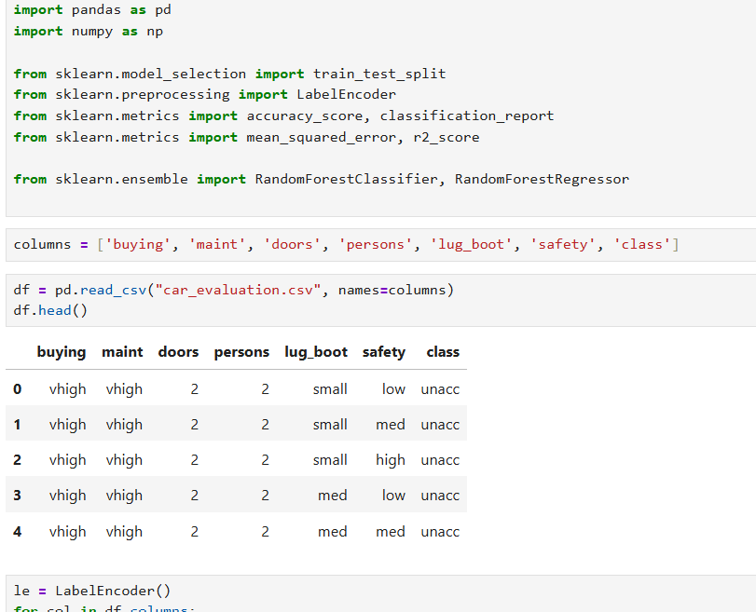
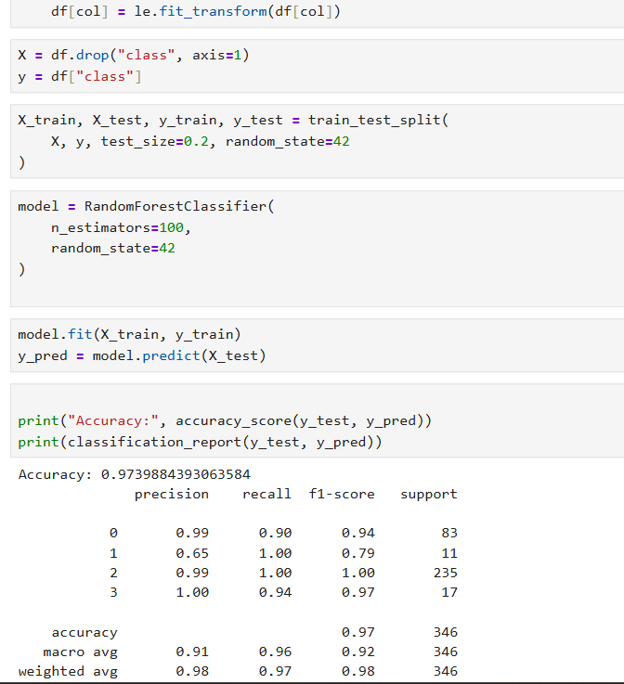
2. 🏠 Melbourne Housing Market (Regression)
- Goal: Predict the Sale Price of houses in Melbourne.
- Why it's good: Unlike a single tree, a Random Forest Regressor can capture the complex, non-linear relationships between location, rooms, and price without overfitting to specific neighborhoods.
- Direct Link: Kaggle - Melbourne Housing
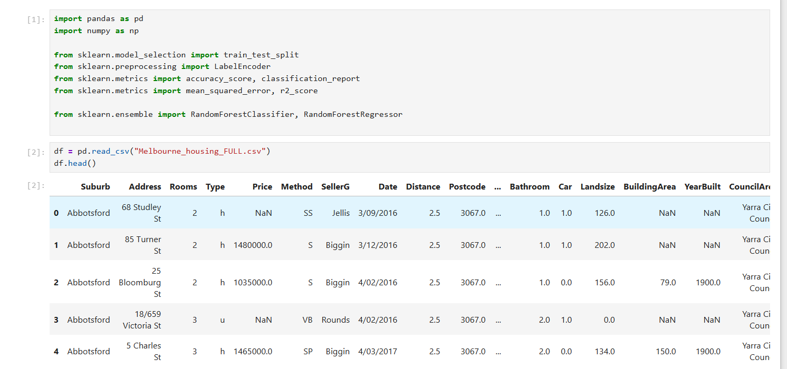
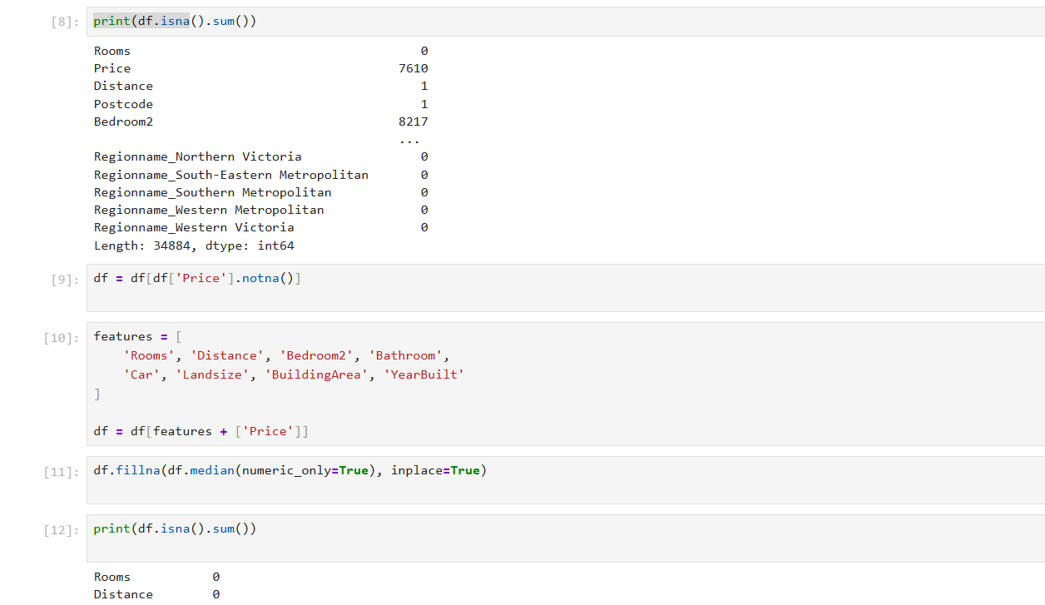

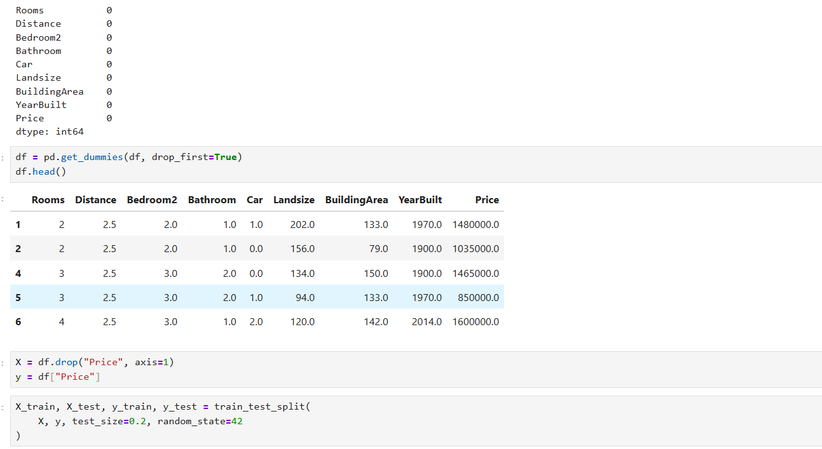
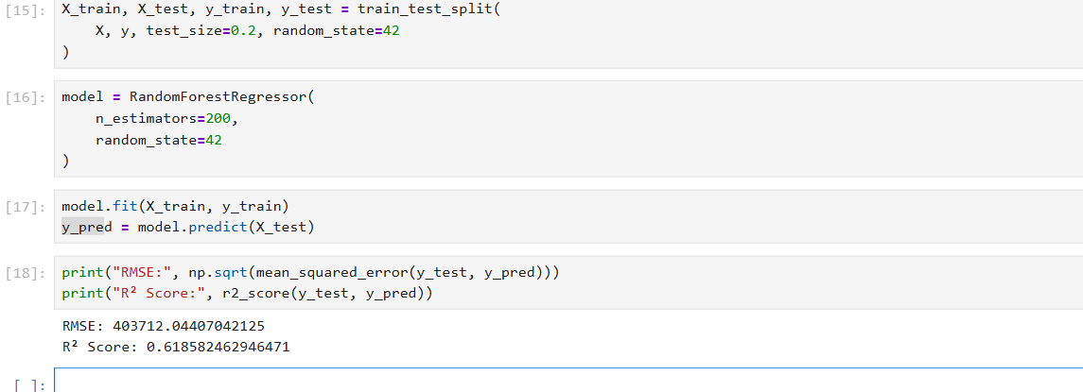

3. 🏦 Bank Marketing Dataset (Imbalanced Classification)
- Goal: Predict if a customer will subscribe to a term deposit.
- Why it's good: In marketing, some features are much more important than others (like "duration of call"). Random Forest has a built-in property called Feature Importance that helps you rank which variables actually drive the decision.
- Direct Link: Kaggle - Bank Marketing
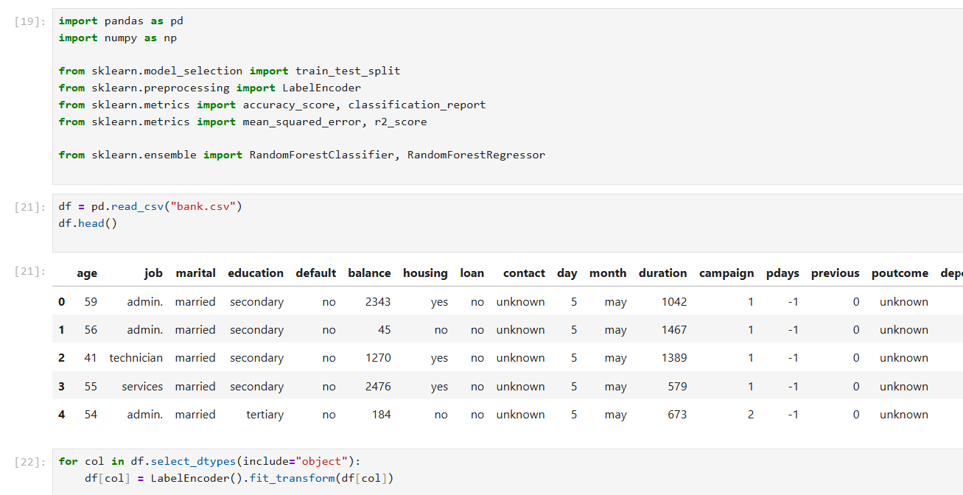
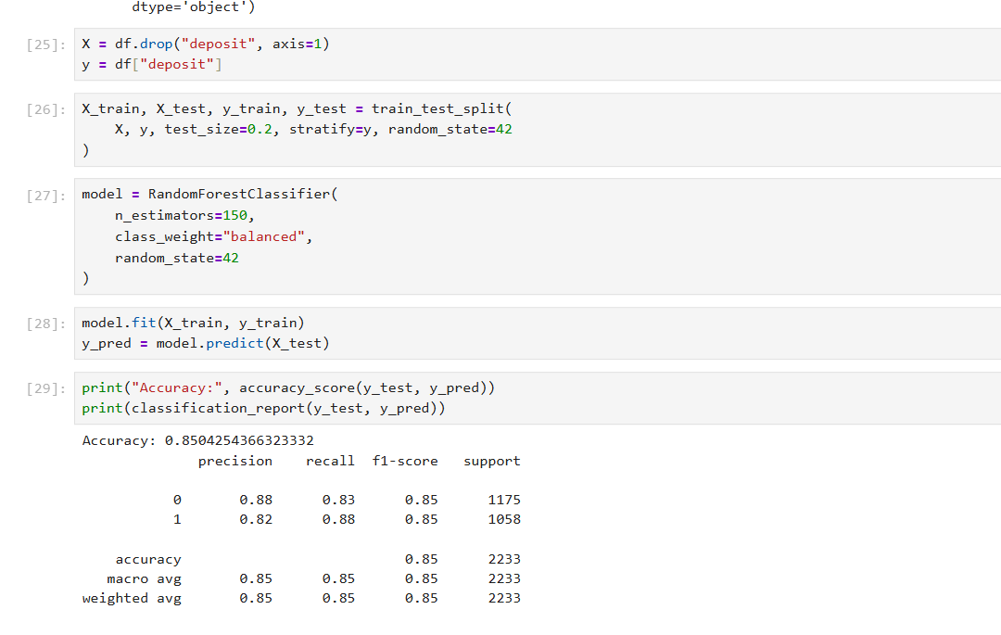
4. 📱 Mobile Price Classification (Multiclass)
- Goal: Predict which "price range" a mobile phone falls into (0, 1, 2, or 3) based on specs like RAM, Battery Power, and 4G capability.
- Why it's good: This is a clean, numerical dataset where you can practice Hyperparameter Tuning. You can experiment with n_estimators (number of trees) to see at what point adding more trees stops improving the accuracy.
- Direct Link: Kaggle - Mobile Price Classification
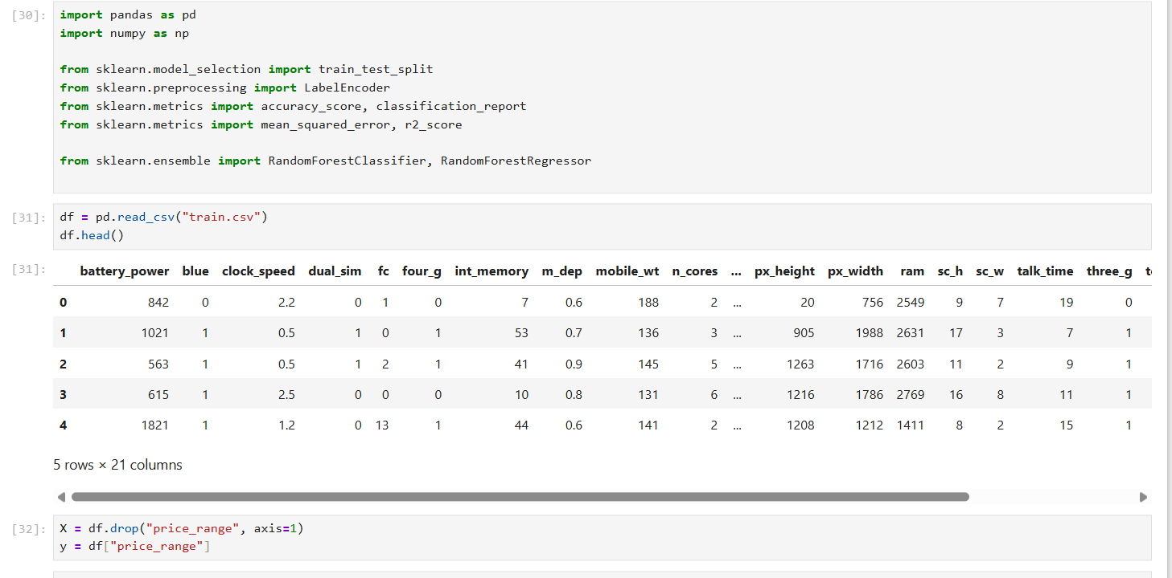
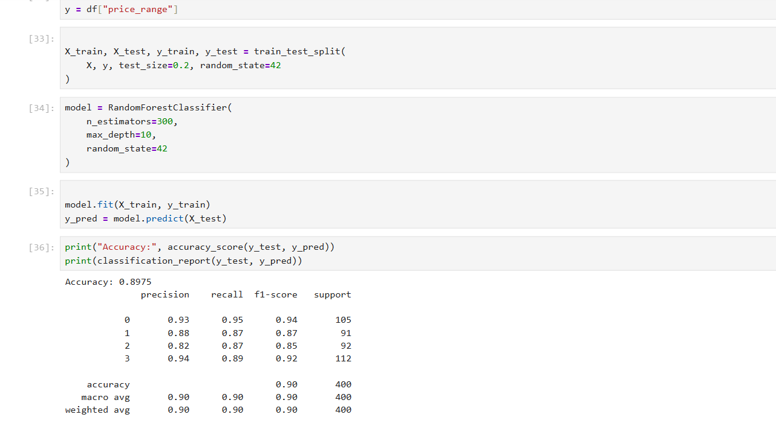
5. 🏥 Heart Failure Clinical Records (Medical Binary Classification)
- Goal: Predict the survival of patients with heart failure.
- Why it's good: Random Forest is excellent for small but "noisy" medical datasets. It uses Out-of-Bag (OOB) error, which is a unique way to validate the model using the data that wasn't picked during the "bagging" process.
- Direct Link: Kaggle - Heart Failure Study
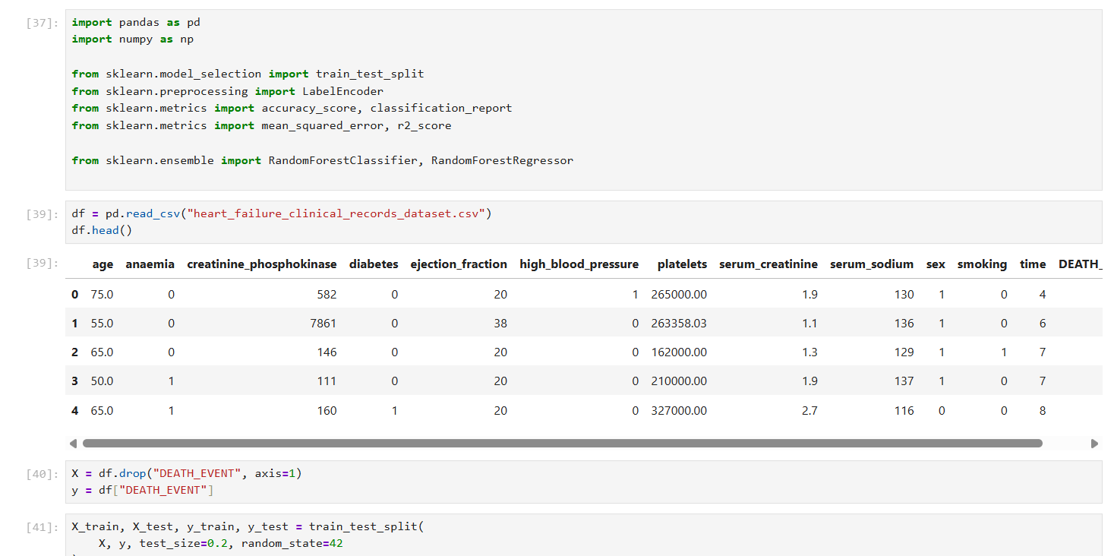

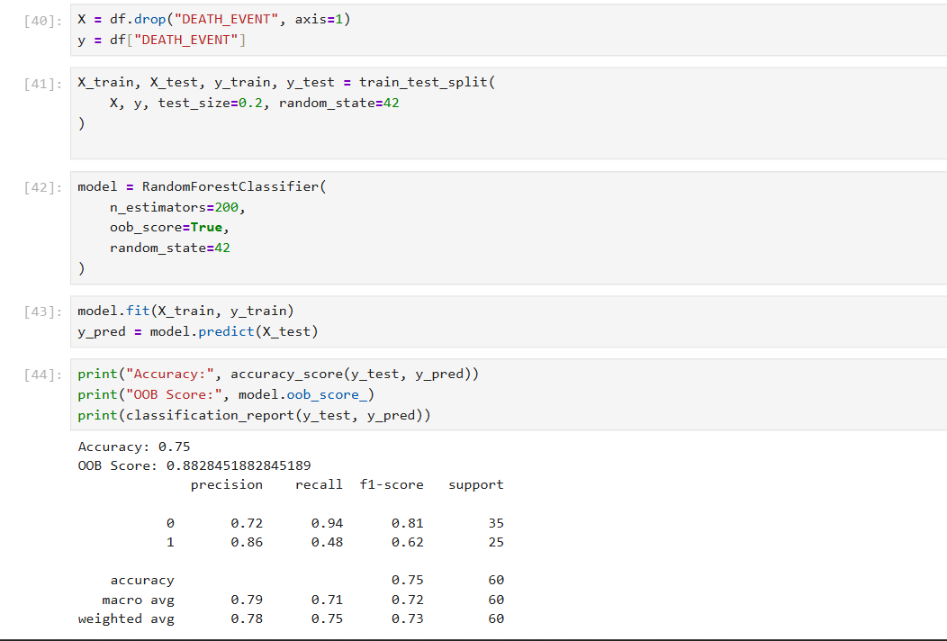

RESOURCES

RESOURCES TO LEARN & PRACTICE RANDOM FOREST

1️⃣ StatQuest – Random Forest (Best Beginner Intuition)
🔗 https://statquest.org/random-forests/
Why it’s great
✔ Visual explanation
✔ Very clear intuition
✔ Zero math fear

2️⃣ StatQuest YouTube – Random Forest Video
🔗 https://www.youtube.com/watch?v=J4Wdy0Wc_xQ
Why use it
✔ Step-by-step explanation
✔ Easy language
✔ Helps retention

3️⃣ Google ML Crash Course – Ensemble Methods
🔗 https://developers.google.com/machine-learning/crash-course/ensemble
Why it helps
✔ Structured learning path
✔ Hands-on exercises
✔ Beginner-friendly modules

4️⃣ Analytics Vidhya – Complete Random Forest Guide
🔗 https://www.analyticsvidhya.com/blog/2021/06/understanding-random-forest/
What you get
✔ Theory + intuition
✔ Diagrams
✔ Pros & cons

5️⃣ Towards Data Science – Random Forest Tutorial
🔗 https://towardsdatascience.com/random-forest-classifier-explained-3437f26e7f8d
Why this is useful
✔ Easy explanation
✔ Code snippets
✔ Intuition + practice

6️⃣ GeeksforGeeks – Random Forest Algorithm
🔗 https://www.geeksforgeeks.org/random-forest-algorithm-in-machine-learning/
Best for
✔ Summary notes
✔ Competitive exam / interview prep
✔ Simple theory

7️⃣ W3Schools – Random Forest in Python
🔗 https://www.w3schools.com/python/python_ml_random_forest.asp
Why beginners like it
✔ Very simple Python code
✔ Entry-level implementation
✔ Easy to follow

8️⃣ scikit-learn Official Docs – Ensemble Methods
🔗 https://scikit-learn.org/stable/modules/ensemble.html#random-forests
Why this matters
✔ Official API reference
✔ Correct usage
✔ Used in real projects

9️⃣ Kaggle – Random Forest Practice Notebooks
🔗 https://www.kaggle.com/code
(Search: “Random Forest classification beginner”)
Why this is awesome
✔ Real datasets
✔ Code you can run in browser
✔ Community examples

🔟 DataCamp – Random Forest Tutorial
🔗 https://www.datacamp.com/tutorial/random-forests-classifier-python
Good for
✔ Practical explanation
✔ Python examples
✔ Intermediate level

🟢 BONUS PRACTICE LINKS (Extra if you want more)
🔹 Machine Learning Mastery – Random Forest From Scratch
🔗 https://machinelearningmastery.com/random-forest-ensemble-in-python/
✔ Intuition + code
✔ Beginner-to-intermediate

STEP 0: First Understand the Problem
Imagine you want to predict pass/fail of students.
You use a Decision Tree:
- If marks > 40 → Pass
- If attendance > 75 → Pass
- Else → Fail
Decision Trees are:
✅ Easy to understand
❌ But they overfit (memorize training data)
👉 Random Forest was invented to fix this problem

STEP 1: What is Random Forest?
Random Forest = Many Decision Trees + Smart Randomness + Voting
Instead of one tree, Random Forest builds hundreds of trees and combines their answers.
Think like this:
Ask 100 teachers for a decision instead of just one teacher.

STEP 2: Bootstrapping – Creating Random Datasets
Suppose you have 1000 student records.
Random Forest does this:
- Randomly picks 1000 records with replacement
- Some records repeat
- Some records are left out
This creates different datasets for each tree.
Why?
So that each tree sees different data → trees become diverse → better learning
This is called Bootstrap Sampling.

STEP 3: Building Many Decision Trees
Now:
- Tree 1 is trained on Dataset 1
- Tree 2 is trained on Dataset 2
- Tree 3 is trained on Dataset 3
- … up to 100, 200, or 500 trees
Each tree:
- Grows independently
- Makes its own rules
- Has its own mistakes

STEP 4: Feature Randomness (Very Important 🔥)
In normal Decision Tree:
- At each split, it checks all features
In Random Forest:
- At each split, it checks only a random subset of features
Example:
If you have 10 features:
- Tree may only look at 3 random features to split
Why this is powerful
It prevents:
❌ One strong feature dominating all trees
❌ Trees becoming identical
👉 This increases diversity and accuracy

STEP 5: Making Predictions (Voting System)
Now comes prediction time.
For classification (Pass/Fail):
Each tree gives a vote:
- Tree 1 → Pass
- Tree 2 → Fail
- Tree 3 → Pass
- Tree 4 → Pass
- Tree 5 → Fail
Final result = Majority Vote
Pass = 3
Fail = 2
👉 Final Prediction = Pass

For regression (Marks prediction):
Each tree gives a number:
- Tree 1 → 65
- Tree 2 → 70
- Tree 3 → 60
Final result = Average
👉 (65+70+60)/3 = 65

STEP 6: Why Random Forest is So Powerful
Problem in Decision Tree | How Random Forest fixes it
Overfitting | Many trees average out errors
High variance | Voting reduces noise
Unstable predictions | Stable & robust
Sensitive to data | Handles variation well

STEP 7: Bias–Variance View (Important Concept)
Decision Tree:
- Low bias (learns well)
- High variance (overfits)
Random Forest:
- Low bias
- Low variance
👉 Best of both worlds 🔥

STEP 8: Important Parameters (Beginner Level)
Parameter | Meaning
n_estimators | Number of trees
max_depth | How deep each tree can grow
max_features | How many features to consider at each split
min_samples_split | Minimum samples to split a node

STEP 9: Simple Real-Life Example
Problem: Loan Approval
Each tree may think differently:
- Tree 1 → Income is most important
- Tree 2 → Credit score is most important
- Tree 3 → Job stability is most important
Random Forest combines all opinions → more fair & accurate decision

STEP 10: Why Companies Love Random Forest
Because:
✔ High accuracy
✔ Works on small & large data
✔ Handles missing values
✔ Handles non-linear data
✔ Less tuning required
Used in:
- Banking
- Medical diagnosis
- Fraud detection
- Student prediction
- Customer churn

DATA ENCODINGS

Encoding techniques are essential because most machine learning algorithms cannot handle text; they only understand numbers. To practice these effectively, you need datasets with various types of categorical data: nominal (no order), ordinal (clear order), and high-cardinality (too many categories).
Here are 5 datasets perfect for mastering each encoding type:

1. 👕 Clothes Size & Price (Ordinal Encoding)
- The Data: Includes categories like Small, Medium, Large, and Extra Large.
- Why it's good: This is the perfect use case for Ordinal Encoding. You want the model to know that Large (3) is greater than Small (1). Using One-Hot encoding here would actually lose that valuable "rank" information.
- Direct Link: Kaggle - Apparel Size Dataset
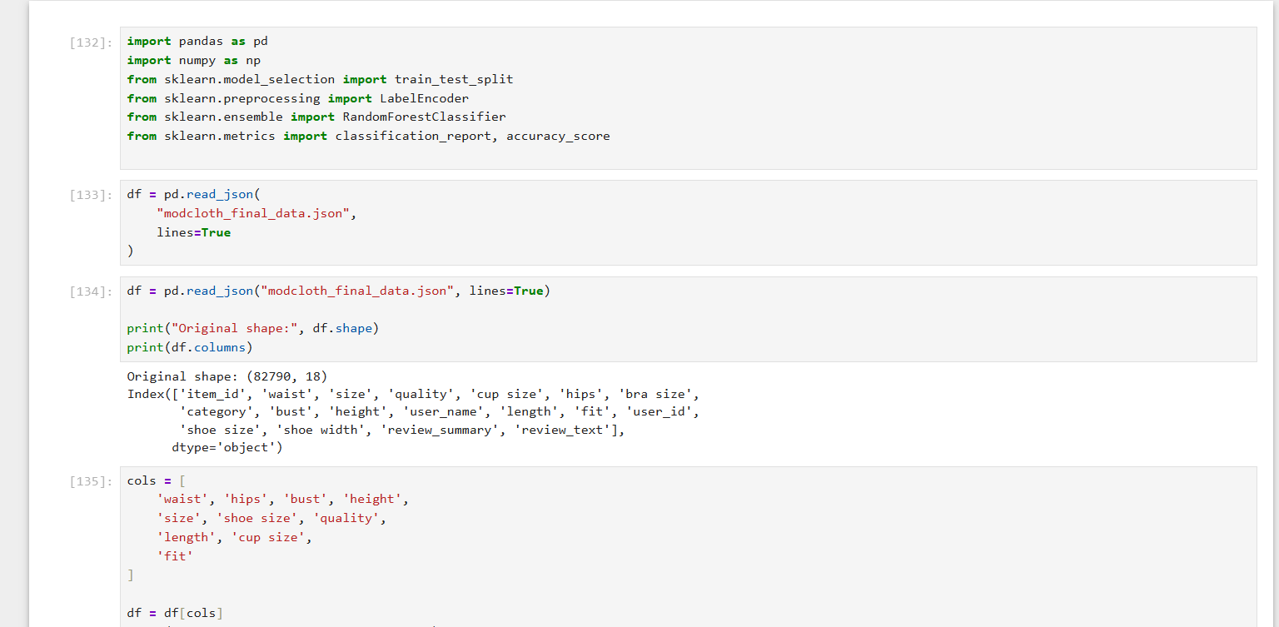
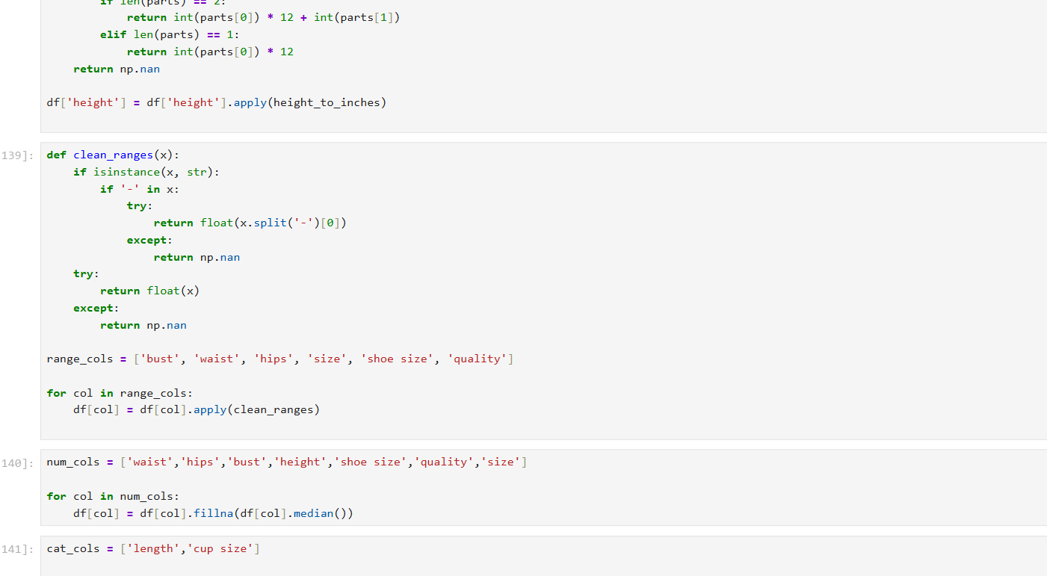
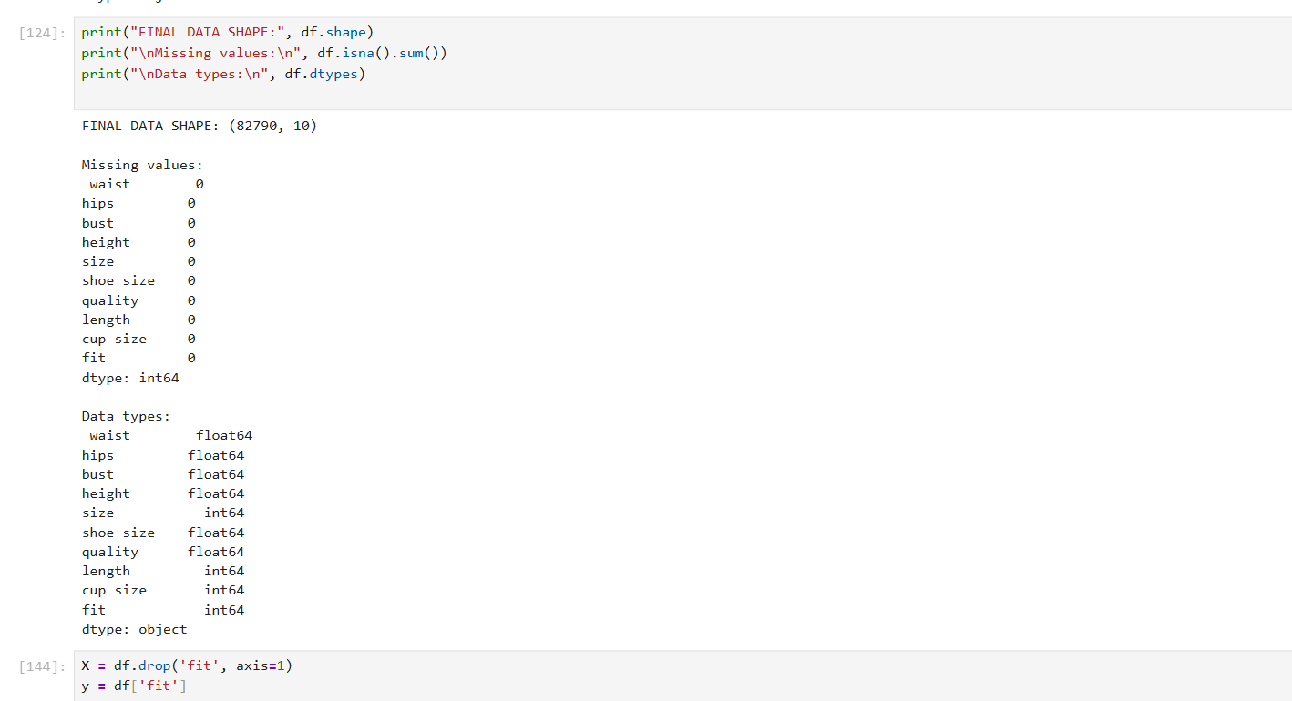
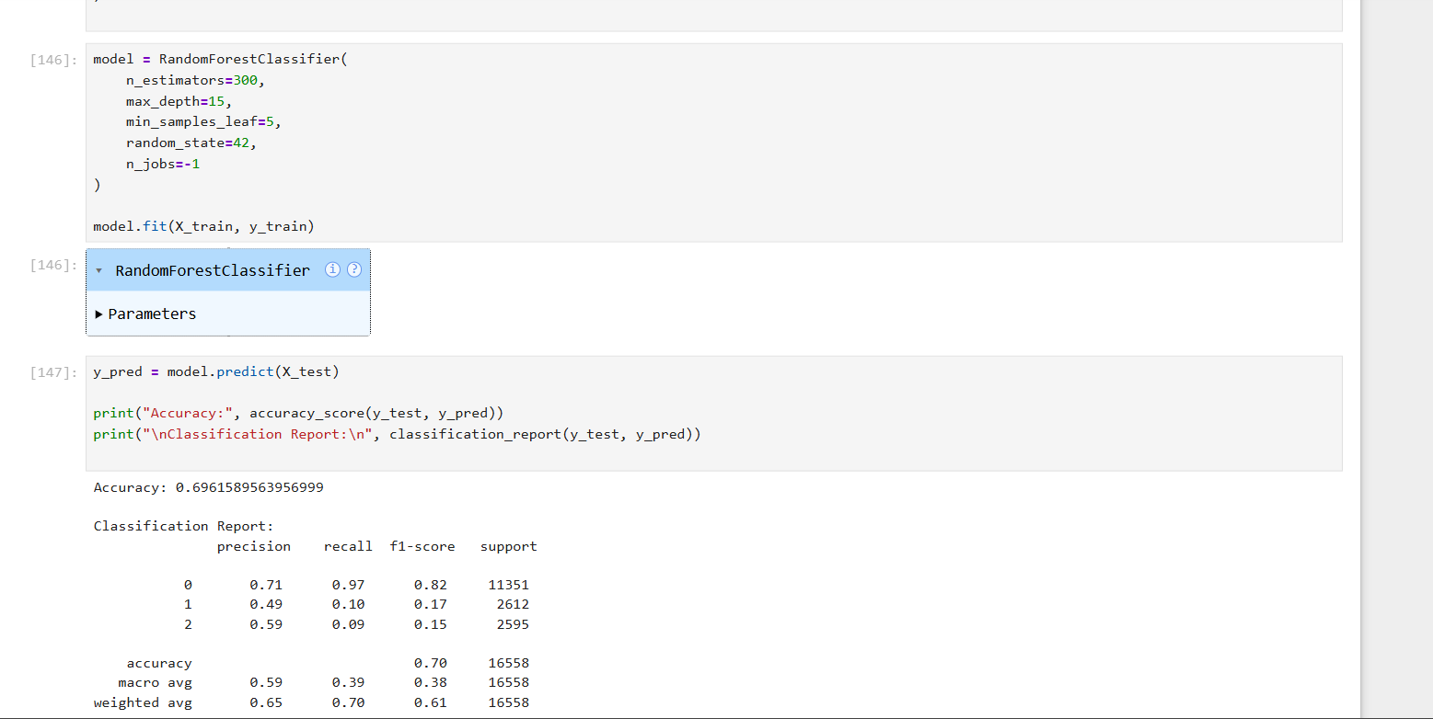
2. 🚢 Titanic Dataset (Label & One-Hot Encoding)
- The Data: Contains Sex (Male/Female) and Embarked (C, Q, S).
- Why it's good: * Use Label Encoding on Sex to turn it into 0 and 1.
  - Use One-Hot Encoding on Embarked. Since there is no "rank" (C is not "better" than Q), One-Hot creates separate columns for each port.
- Direct Link: Kaggle - Titanic
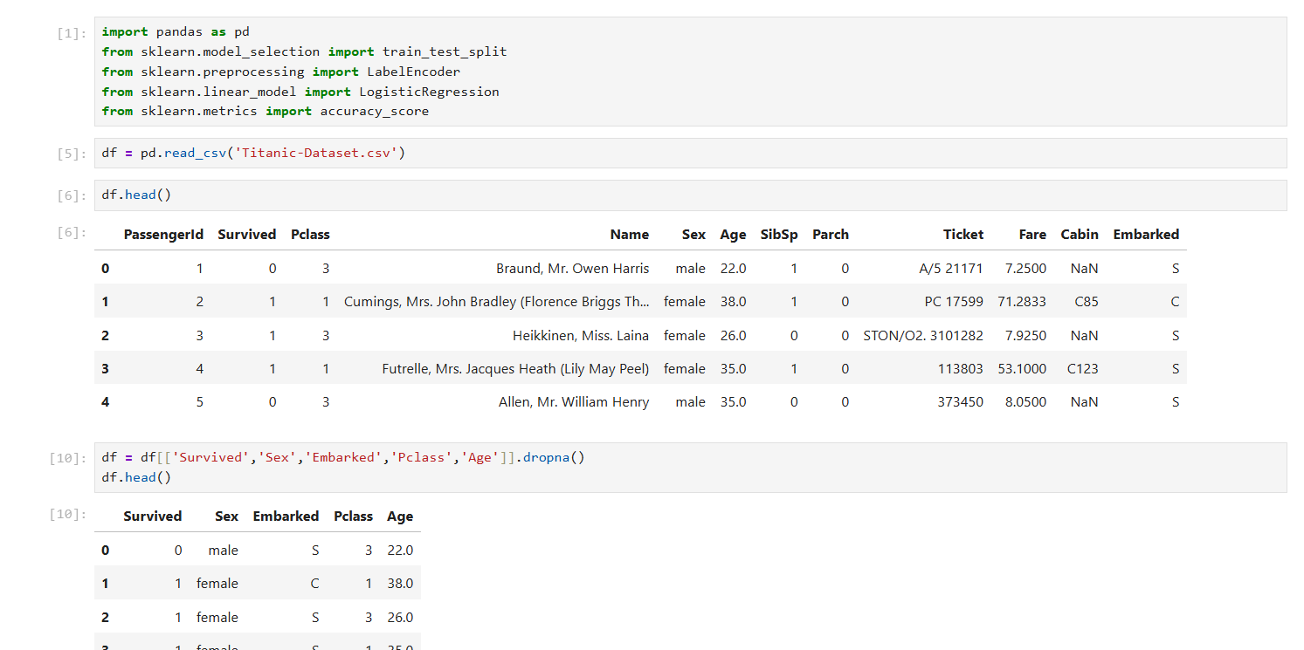
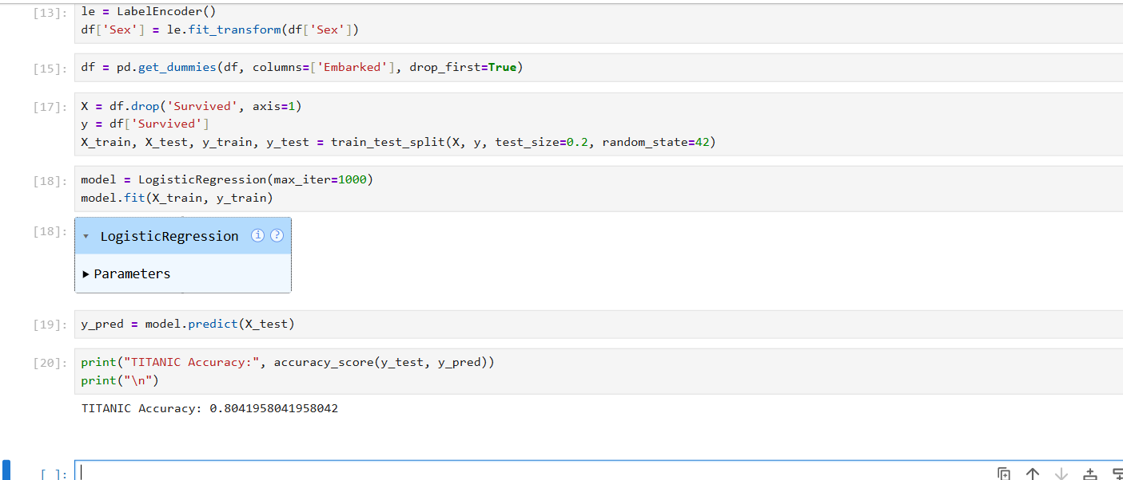
3. 🏎️ Car Evaluation Dataset (Ordinal & Label Encoding)
- The Data: Categories like buying_price (high, med, low) and safety (low, med, high).
- Why it's good: Every single column in this dataset is categorical. It forces you to decide which columns need a specific order (Ordinal) and which are just simple labels.
- Direct Link: Kaggle - Car Evaluation
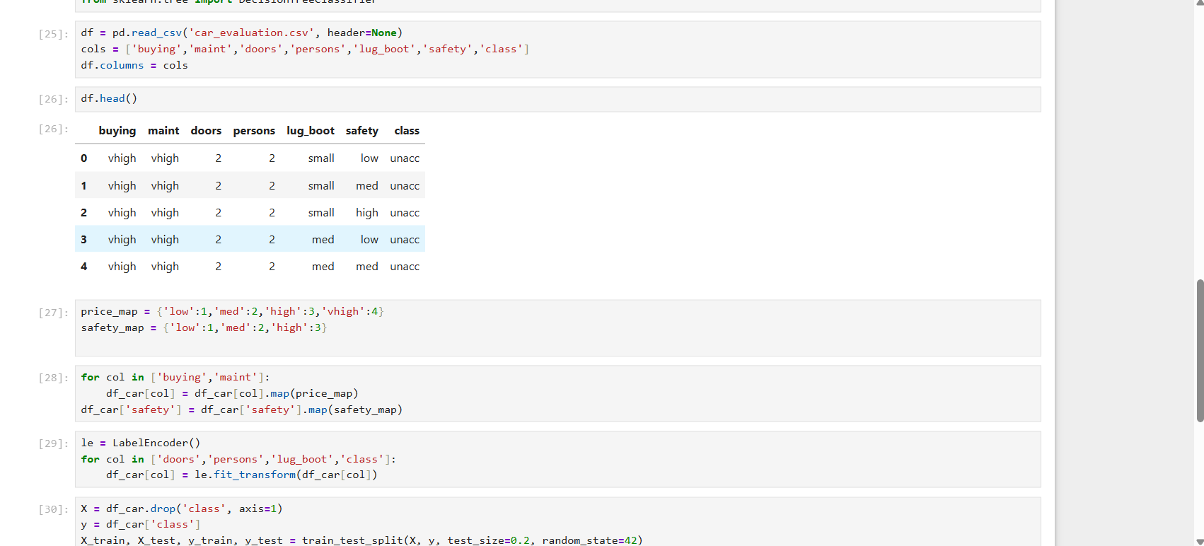
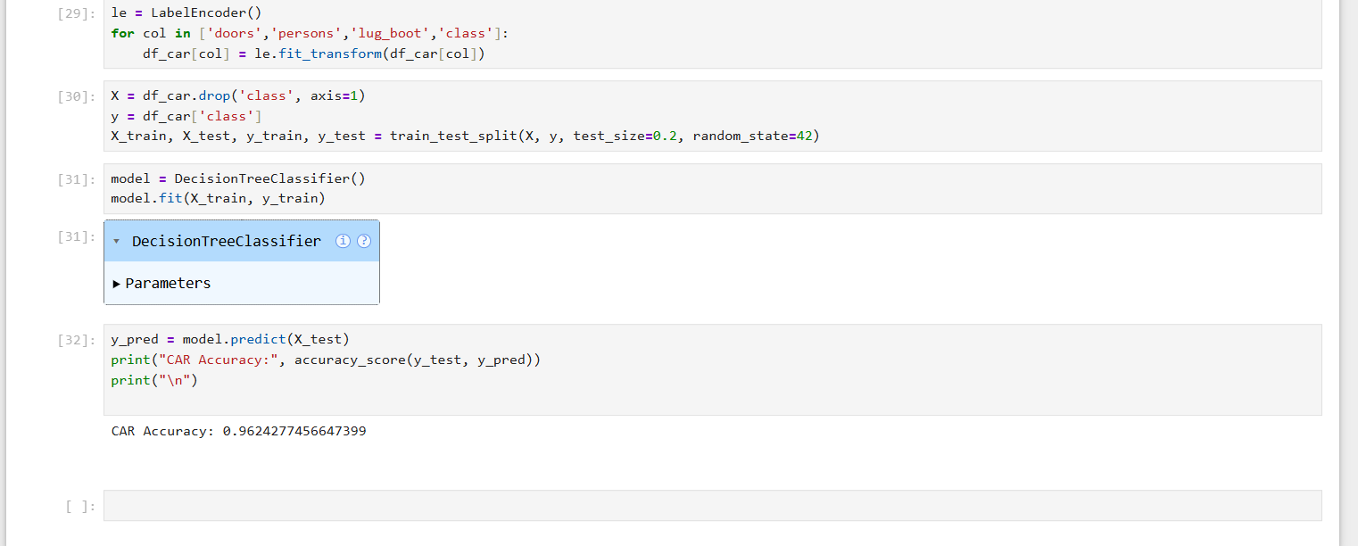
4. 🏘️ Ames Housing Dataset (Binary Encoding)
- The Data: Contains dozens of categorical features like Neighborhood, Condition1, and Exterior1st.
- Why it's good: Some columns have 25+ unique categories. If you use One-Hot encoding, your dataset becomes too "wide" (The Curse of Dimensionality). Binary Encoding is the solution here—it converts the categories into binary digits, keeping the column count low.
- Direct Link: Kaggle - House Prices: Advanced Regression
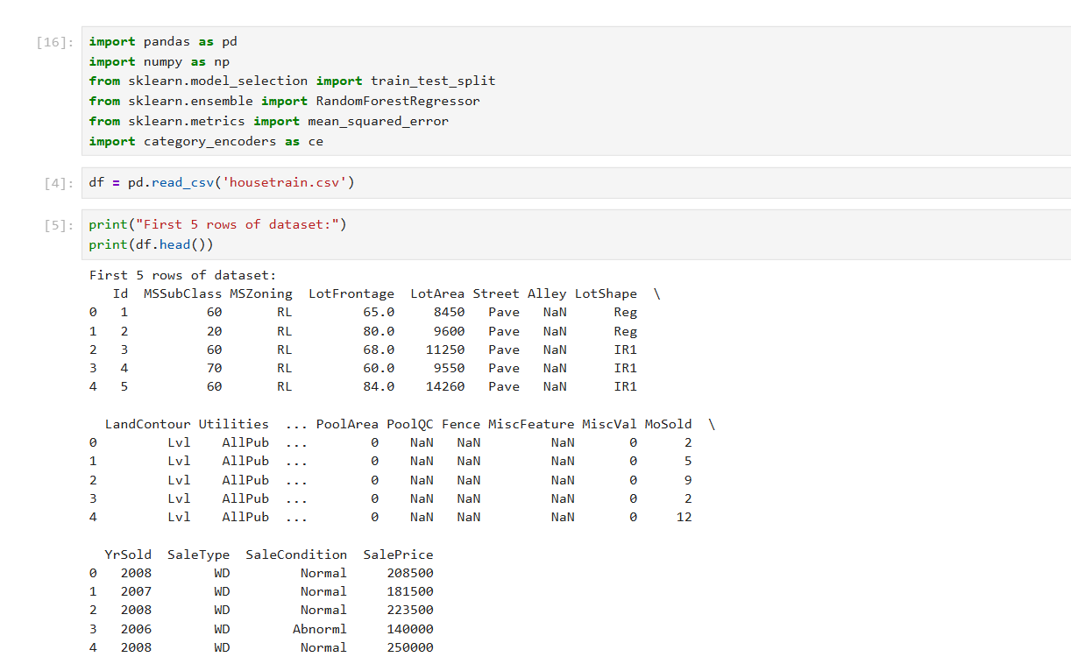
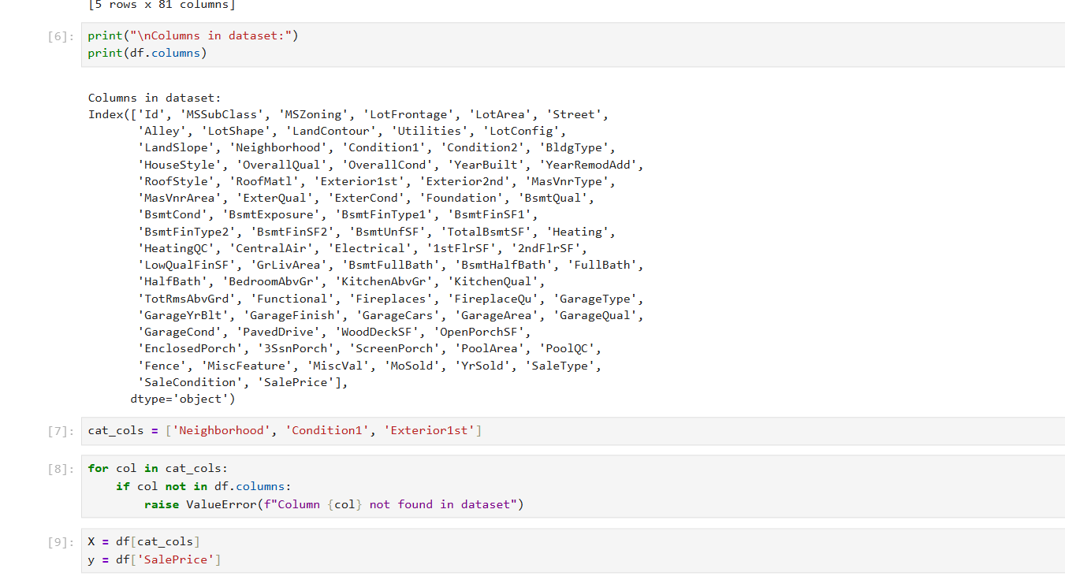
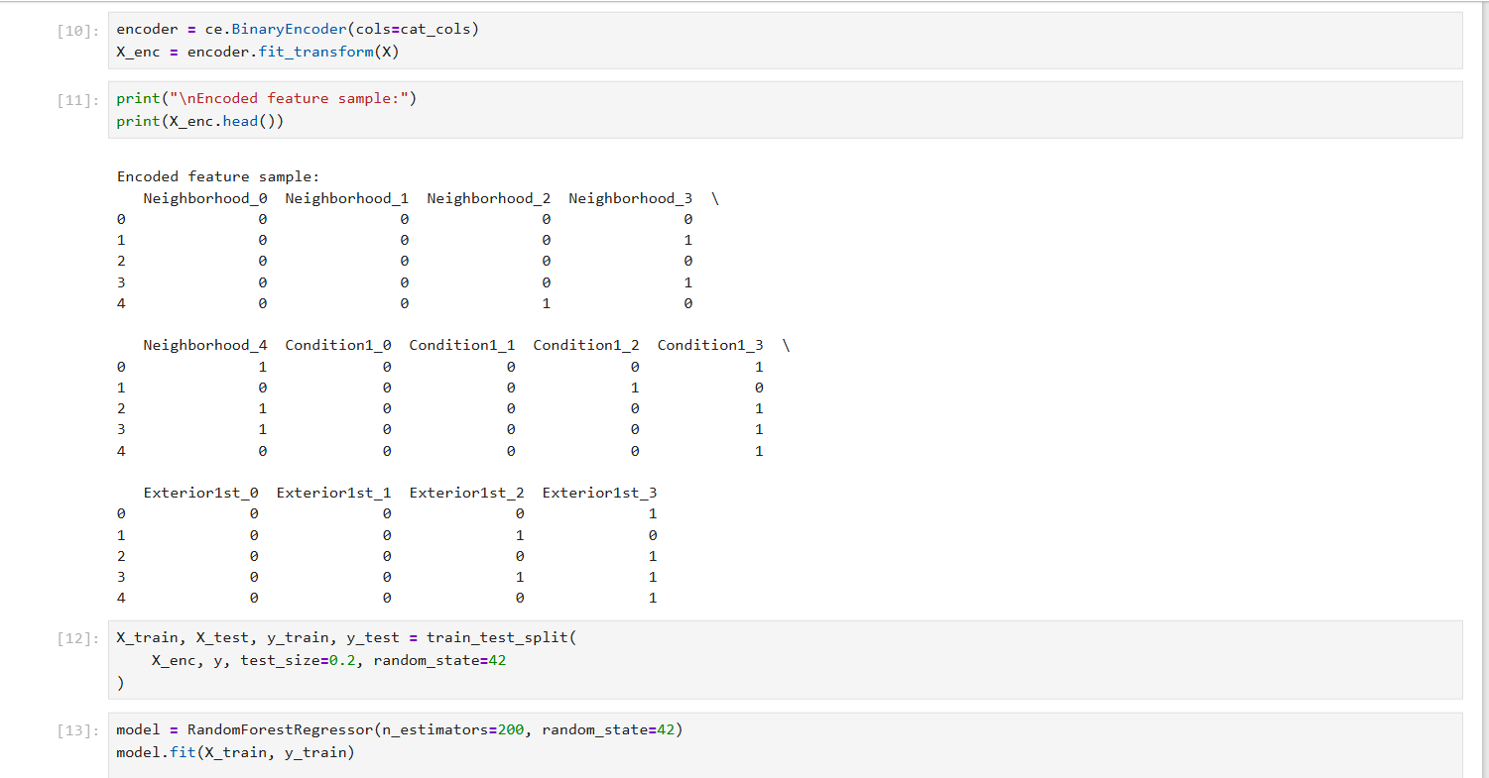
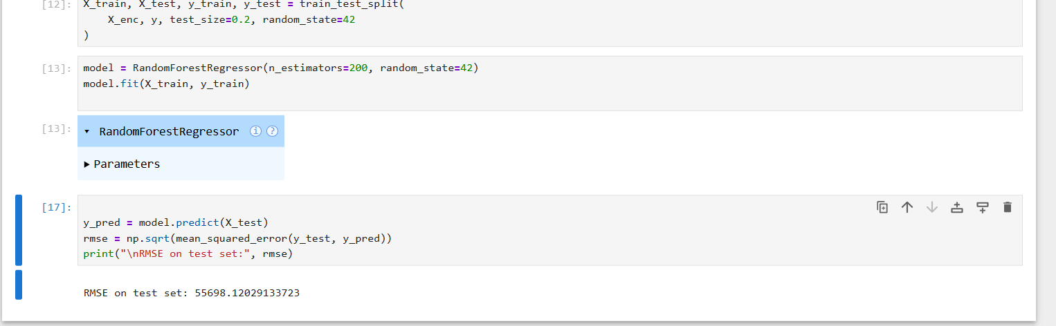

5. 💳 Cat-in-the-Dat (Target Encoding)
- The Data: A dataset specifically designed by Kaggle to test encoding methods. It contains features with High Cardinality (hundreds of unique values).
- Why it's good: When a column has 500 unique values, One-Hot is impossible. Target Encoding replaces the category with the mean of the target variable for that category. It’s a powerful but advanced trick that you must learn to handle carefully to avoid overfitting.
- Direct Link: Kaggle - Categorical Variable Encoding Challenge
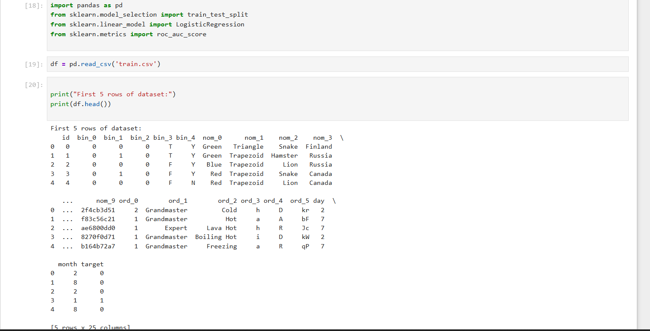
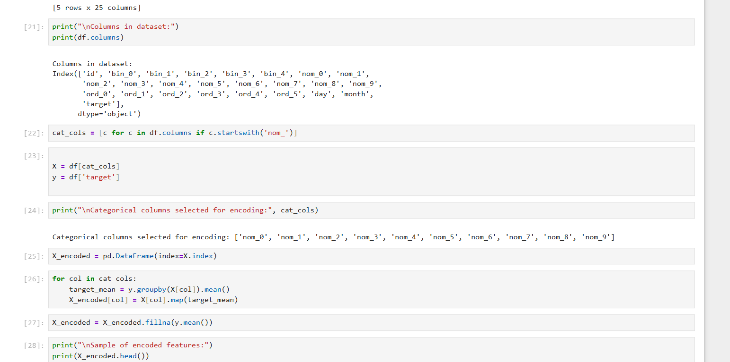
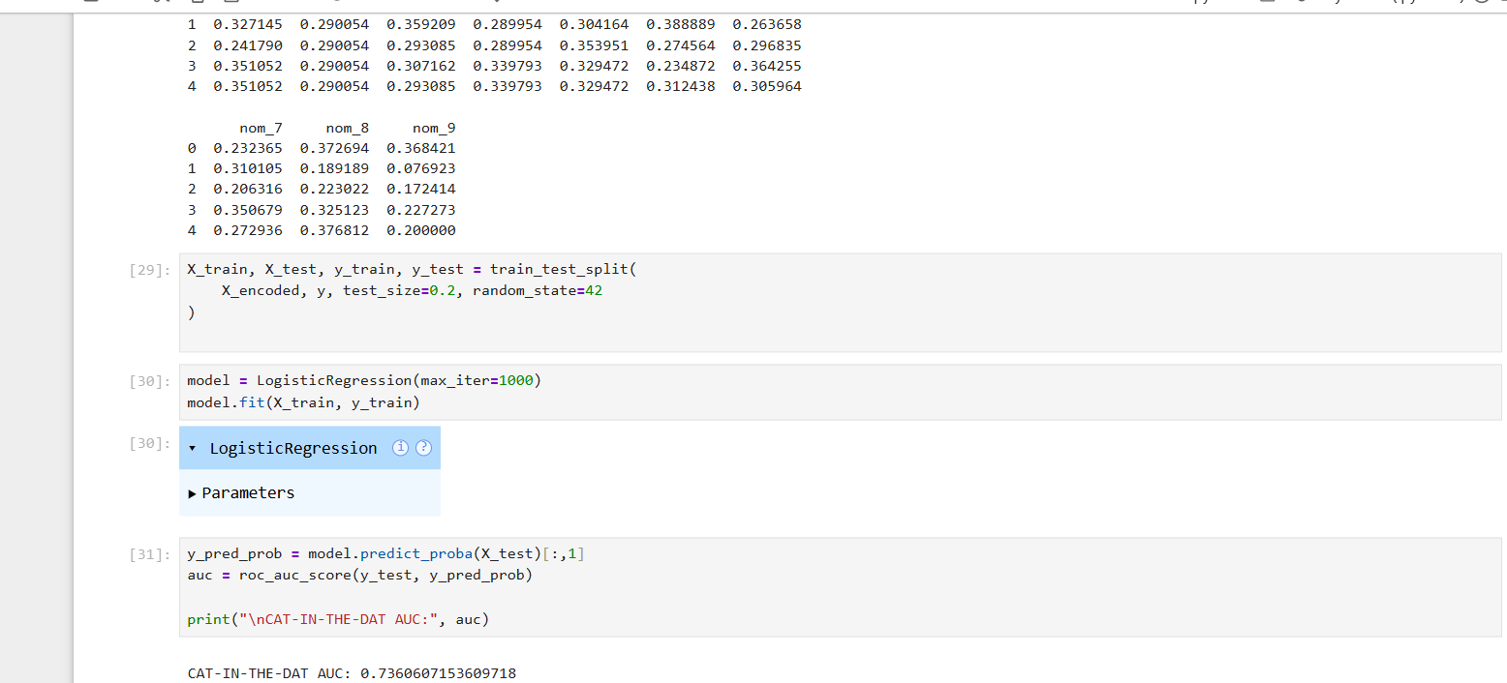
1️⃣ One-Hot Encoding
What it does
Creates separate columns for each category.
Example
Color = Red, Blue

Red → 1 0
Blue → 0 1
When to use
✔ Nominal data (no order)
✔ Logistic Regression, KNN, SVM, Linear models
Python
pd.get_dummies(data, columns=['Color'])

2️⃣ Label Encoding
What it does
Converts categories to numbers
Example
Male → 0
Female → 1
When to use
✔ Binary categories
✔ Tree models (Decision Tree, Random Forest)
Python
from sklearn.preprocessing import LabelEncoder
le = LabelEncoder()
data['Gender'] = le.fit_transform(data['Gender'])

3️⃣ Ordinal Encoding
What it does
Encodes based on order
Example
Low → 1
Medium → 2
High → 3
When to use
✔ Ordered categories
✔ Education level, ratings, size
Python
size_map = {'Small':1, 'Medium':2, 'Large':3}
data['Size'] = data['Size'].map(size_map)

4️⃣ Target Encoding (Mean Encoding)
What it does
Replaces category with mean of target value
Example
City = Delhi → 0.62
City = Mumbai → 0.45
When to use
✔ High-cardinality features
✔ Large datasets
✔ Kaggle competitions
Python
import category_encoders as ce
encoder = ce.TargetEncoder(cols=['City'])
data['City'] = encoder.fit_transform(data['City'], target)

5️⃣ Binary Encoding
What it does
Converts category into binary digits
When to use
✔ Many unique values
✔ Reduces memory compared to one-hot
Python
encoder = ce.BinaryEncoder(cols=['City'])
data = encoder.fit_transform(data)

📌 1️⃣ ONE-HOT ENCODING (MOST IMPORTANT)
📘 Beginner Friendly
• W3Schools — One-Hot Encoding
🔗 https://www.w3schools.com/python/python_ml_one_hot.asp
🧠 Detailed Explanation
• Analytics Vidhya — One-Hot Encoding
🔗 https://www.analyticsvidhya.com/blog/2020/08/types-of-categorical-data-encoding/
📊 Python Practice
• Machine Learning Mastery — One-Hot Encoding in Python
🔗 https://machinelearningmastery.com/one-hot-encoding-for-categorical-data/

📌 2️⃣ LABEL ENCODING
📘 Beginner Friendly
• W3Schools — Label Encoding
🔗 https://www.w3schools.com/python/python_ml_labelencoder.asp
🧠 Clear Explanation
• GeeksforGeeks — Label Encoding
🔗 https://www.geeksforgeeks.org/label-encoding-versus-one-hot-encoding/
📊 Python Tutorial
• Analytics Vidhya — Label Encoding
🔗 https://www.analyticsvidhya.com/blog/2021/06/encoding-techniques-in-machine-learning/

📌 3️⃣ ORDINAL ENCODING
🧠 Intuitive Explanation
• Towards Data Science — Ordinal Encoding
🔗 https://towardsdatascience.com/all-about-categorical-encoding-for-machine-learning-f5f0b07f938b
📘 Simple Guide
• Analytics Vidhya — Encoding Techniques
🔗 https://www.analyticsvidhya.com/blog/2021/06/encoding-techniques-for-categorical-data/
📊 Python Code
• Stack Abuse — Ordinal Encoding in Python
🔗 https://stackabuse.com/ordinal-encoding-with-scikit-learn-in-python/

📌 4️⃣ TARGET ENCODING (MEAN ENCODING)
🧠 Explanation (Beginner Friendly)
• Analytics Vidhya — Target Encoding
🔗 https://www.analyticsvidhya.com/blog/2021/06/target-encoding-for-categorical-features/
📘 Concept + Intuition
• Towards Data Science — Mean Encoding
🔗 https://towardsdatascience.com/target-encoding-for-categorical-features-in-python-68e9e7af0853
📊 Python Practice
• Machine Learning Mastery — Target Encoding
🔗 https://machinelearningmastery.com/target-encoding-for-categorical-features/

📌 5️⃣ BINARY ENCODING
🧠 Clear Explanation
• Analytics Vidhya — Binary Encoding
🔗 https://www.analyticsvidhya.com/blog/2021/06/categorical-encoding-techniques-for-machine-learning/
📘 Intro with Diagrams
• Towards Data Science — Binary Encoding
🔗 https://towardsdatascience.com/binary-encoding-categorical-data-for-machine-learning-2f26e5aae0d9
📊 Python Practice
• Category Encoders Library (Binary Encoding)
🔗 https://contrib.scikit-learn.org/category_encoders/binary.html

🧠 ADDITIONAL GENERAL ENCODING RESOURCES
📘 Comprehensive Guide (Beginner → Advanced)
• Analytics Vidhya — All Encoding Techniques
🔗 https://www.analyticsvidhya.com/blog/2021/06/encoding-techniques-in-machine-learning/
📊 Coding All Encodings in One Place
• Machine Learning Mastery (Full Encoding Guide)
🔗 https://machinelearningmastery.com/transform-feature-categorical-data-numerical/
🧠 Comparison & When to Use Which
• Towards Data Science – Categorical Encoding Comparison
🔗 https://towardsdatascience.com/categorical-data-encoding-886f8898125f

LeetCode Problems : Explain and attach screenshot
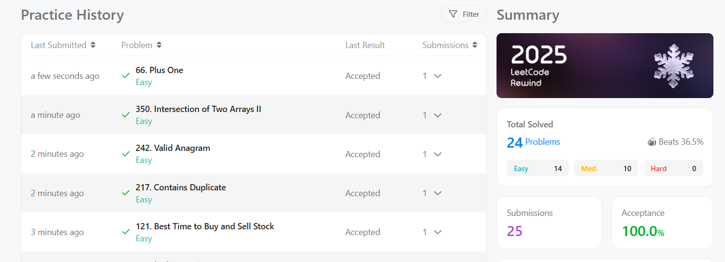

Explain your GitHub submission and attach your submitted Repo screenshot

Explain your LinkedIn Post and attach your submitted Post screenshot
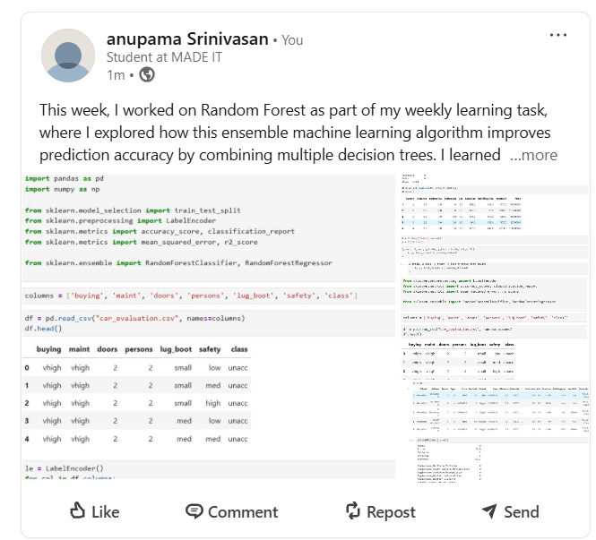

Attach the link of your First Video (YouTube)
https://www.youtube.com/watch?v=YmQ1Yq2ZqGQ

Attach the link of your Second Video (YouTube)
https://youtu.be/rq_xUb4zGSU?si=5oKr4gTmzL-cwboO

MORE RESOURCES
- Label
- One-Hot
- Ordinal
- Binary
- Target (Mean)

📅 7-DAY LEARNING PLAN — DATA ENCODING

🟢 DAY 1 – Understanding Categorical Data + Label Encoding
🎯 Goal
Understand what categorical data is and how Label Encoding works.
📘 Learn
- What is categorical data?
- Why encoding is needed
- What is Label Encoding?
🌐 Resources
- W3Schools – Label Encoding
https://www.w3schools.com/python/python_ml_labelencoder.asp
- GeeksforGeeks – Label vs One-Hot
https://www.geeksforgeeks.org/label-encoding-versus-one-hot-encoding/
💻 Practice
from sklearn.preprocessing import LabelEncoder
import pandas as pd

data = pd.DataFrame({'Gender':['Male','Female','Female','Male']})
le = LabelEncoder()
data['Gender_encoded'] = le.fit_transform(data['Gender'])
print(data)
✅ Output
✔ Understand why Male → 0, Female → 1
✔ Know when to use Label Encoding

🟢 DAY 2 – One-Hot Encoding
🎯 Goal
Master One-Hot Encoding completely.
📘 Learn
- Nominal data
- Dummy variables
- Dummy variable trap
🌐 Resources
- W3Schools – One-Hot Encoding
https://www.w3schools.com/python/python_ml_one_hot.asp
- Analytics Vidhya – One-Hot Encoding
https://www.analyticsvidhya.com/blog/2020/08/types-of-categorical-data-encoding/
💻 Practice
import pandas as pd

data = pd.DataFrame({'Color':['Red','Blue','Green','Red']})
encoded = pd.get_dummies(data, columns=['Color'])
print(encoded)
✅ Output
✔ New columns created
✔ Understand why models need this

🟢 DAY 3 – Ordinal Encoding (Ordered Categories)
🎯 Goal
Learn how to encode ordered data correctly.
📘 Learn
- Ordinal vs Nominal
- Why order matters
🌐 Resources
- StackAbuse – Ordinal Encoding
https://stackabuse.com/ordinal-encoding-with-scikit-learn-in-python/
- Analytics Vidhya – Encoding Techniques
https://www.analyticsvidhya.com/blog/2021/06/encoding-techniques-for-categorical-data/

💻 Practice
import pandas as pd

data = pd.DataFrame({'Size':['Small','Medium','Large','Small']})
size_map = {'Small':1, 'Medium':2, 'Large':3}
data['Size_encoded'] = data['Size'].map(size_map)
print(data)
✅ Output
✔ Small → 1, Medium → 2, Large → 3
✔ Understand ordered meaning

🟢 DAY 4 – Binary Encoding (High Cardinality)
🎯 Goal
Learn encoding for many unique values.
📘 Learn
- What is high cardinality?
- Why One-Hot fails here
🌐 Resources
- Towards Data Science – Binary Encoding
https://towardsdatascience.com/binary-encoding-categorical-data-for-machine-learning-2f26e5aae0d9
- Category Encoders Docs
https://contrib.scikit-learn.org/category_encoders/binary.html
💻 Practice
import pandas as pd
import category_encoders as ce

data = pd.DataFrame({'City':['Delhi','Mumbai','Chennai','Kochi','Delhi']})
encoder = ce.BinaryEncoder(cols=['City'])
encoded = encoder.fit_transform(data)
print(encoded)
✅ Output
✔ City converted into binary columns
✔ Understand memory advantage

🟢 DAY 5 – Target Encoding (Mean Encoding)
🎯 Goal
Understand advanced encoding used in competitions.
📘 Learn
- What is target leakage?
- Why target encoding works
🌐 Resources
- Analytics Vidhya – Target Encoding
https://www.analyticsvidhya.com/blog/2021/06/target-encoding-for-categorical-features/
- Machine Learning Mastery – Target Encoding
https://machinelearningmastery.com/target-encoding-for-categorical-features/
💻 Practice
import pandas as pd
import category_encoders as ce

data = pd.DataFrame({
'City':['Delhi','Mumbai','Delhi','Chennai','Mumbai'],
'Target':[1,0,1,0,1]
})

encoder = ce.TargetEncoder(cols=['City'])
encoded = encoder.fit_transform(data[['City']], data['Target'])
print(encoded)
✅ Output
✔ City replaced with mean target
✔ Understand power + risk

🟢 DAY 6 – When to Use Which Encoding (VERY IMPORTANT)
🎯 Goal
Learn decision making.
📘 Learn
Situation | Encoding
Binary | Label
Nominal | One-Hot
Ordered | Ordinal
Many values | Binary
Large data | Target
🌐 Resource
- Analytics Vidhya – All Encodings
https://www.analyticsvidhya.com/blog/2021/06/encoding-techniques-in-machine-learning/
💻 Practice
Take any dataset (Titanic / Student / Loan) and:
- Identify categorical columns
- Decide encoding for each
✅ Output
✔ Correct encoding selection
✔ Real-world thinking

🟢 DAY 7 – Mini Project
🎯 Goal
Apply everything together.
📊 Dataset
Use Titanic dataset or Student performance dataset
💻 Tasks
- Load dataset
- Identify categorical columns
- Apply:
  - Label encoding to binary
  - One-hot to nominal
  - Ordinal to ordered
- Train a model (Logistic / Tree)
- Check accuracy

RANDOM FOREST resources

🟢 DAY 1 – Foundation: Decision Tree + Why Random Forest Exists
🎯 Goal
Understand Decision Trees and their problems, so Random Forest makes sense.
📘 Learn
- What is a Decision Tree?
- How splitting works
- Overfitting problem
- Why one tree is risky
🌐 Resources
- StatQuest – Decision Trees
https://statquest.org/decision-trees/
- YouTube (StatQuest):
https://www.youtube.com/watch?v=7VeUPuFGJHk
💻 Practice
- Use sklearn DecisionTreeClassifier
- Train on Breast Cancer dataset
- Check train accuracy vs test accuracy
✅ Output
✔ Understand overfitting
✔ Know why Random Forest is needed

🟢 DAY 2 – What is Random Forest (Core Concept Day 🔥)
🎯 Goal
Understand what Random Forest really is.
📘 Learn
- Bagging (Bootstrap Aggregation)
- Why multiple trees
- Voting system
🌐 Resources
- StatQuest – Random Forest
https://statquest.org/random-forests/
- Video:
https://www.youtube.com/watch?v=J4Wdy0Wc_xQ
💻 Practice
- Draw diagram of forest + trees
- Explain Random Forest in your own words
✅ Output
✔ Clear mental picture of Random Forest

🟢 DAY 3 – Feature Randomness + How Trees Are Built
🎯 Goal
Understand how Random Forest creates different trees.
📘 Learn
- Feature randomness
- max_features
- How splits differ from tree to tree
🌐 Resources
- Analytics Vidhya – Random Forest Guide
https://www.analyticsvidhya.com/blog/2021/06/understanding-random-forest/
💻 Practice
from sklearn.ensemble import RandomForestClassifier
model = RandomForestClassifier(n_estimators=10, max_features=2, random_state=42)
Change max_features and observe results.
✅ Output
✔ Understand diversity in trees

🟢 DAY 4 – Full Python Implementation
🎯 Goal
Build your first complete Random Forest model.
📘 Learn
- n_estimators
- max_depth
- min_samples_split
🌐 Resource
- W3Schools – Random Forest in Python
https://www.w3schools.com/python/python_ml_random_forest.asp
💻 Practice
- Load dataset
- Train RandomForestClassifier
- Predict results
- Print accuracy
✅ Output
✔ Model running successfully
✔ No confusion in code

🟢 DAY 5 – Model Evaluation + Feature Importance
🎯 Goal
Learn how to evaluate Random Forest properly.
📘 Learn
- Confusion Matrix
- Accuracy, Precision, Recall
- Feature importance
🌐 Resources
- scikit-learn Docs – Random Forest
https://scikit-learn.org/stable/modules/ensemble.html#random-forests
- GeeksforGeeks – Random Forest
https://www.geeksforgeeks.org/random-forest-algorithm-in-machine-learning/
💻 Practice
model.feature_importances_
Plot top 10 features.
✅ Output
✔ Know which features matter
✔ Understand how forest decides

🟢 DAY 6 – Bias–Variance + Overfitting Control
🎯 Goal
Understand why Random Forest is stable.
📘 Learn
- Bias vs Variance
- Overfitting vs Underfitting
- Why Random Forest reduces variance
🌐 Resources
- StatQuest – Bias vs Variance
https://www.youtube.com/watch?v=EuBBz3bI-aA
- Machine Learning Mastery
https://machinelearningmastery.com/gentle-introduction-to-the-bias-variance-trade-off-in-machine-learning/
💻 Practice
- Train model with:
  - low depth
  - high depth
- Compare train & test accuracy
✅ Output
✔ Identify overfitting
✔ Control it using parameters

🟢 DAY 7 – Mini Project
🎯 Goal
Apply everything together.
📊 Dataset (choose one)
- Titanic
- Student Performance
- Diabetes
- Loan Prediction
💻 Tasks
- Load dataset
- Clean data
- Encode categorical features
- Train Random Forest
- Evaluate using:
  - Accuracy
  - Confusion Matrix
- Print feature importance
- Explain result in words

